**Assignment 3 on ES6 and Javascript**

1. **Promises:** Create 2 promises, one generates value of x & another generates value of you. Write a program to print sum of x & y. (Use Promise.all)

Code:

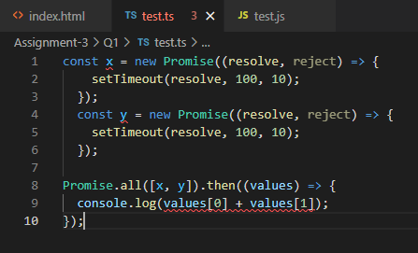

Output:

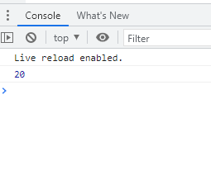

1. **TypeScript classes & types:** Write a class Account with attributes id, name, balance. Add two sub classes SavingAccount & CurrentAccount having specific attribute interest & cash_credit respectively. Create multiple saving & current account objects. Write a functionality to find out total balance in the bank.

Code:

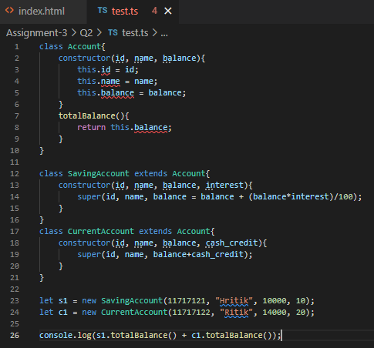

Output:

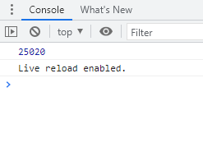

1. **TypeScript Interfaces:** Write an interface Printable. Create 2 objects circle & employee those implement Printable interface. Write a function printAll() that takes all objects as argument & invoke print() method on every object.

Code:

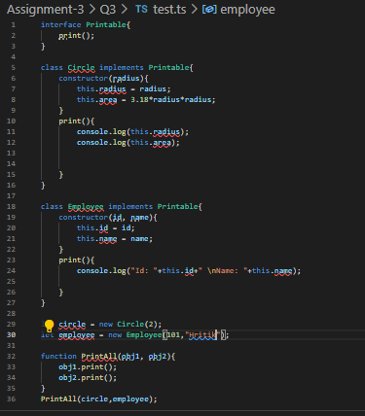

Output:

